**Churn Analysis of Telco Customers**

### 1. Introduction

**Project Title:** Churn Analysis of Telco Customers

**Objective:** Analyzing the churn rate among customers of a telecommunications company using SQL for data retrieval and Power BI for data visualization.

**Tools Used:** MySQL, Power BI

**Dataset:** IBM Telco Customer Churn dataset

### 2. Data Preparation

The dataset used for this analysis contains customer data including demographic information, services subscribed, and financial details. The primary focus is to analyze factors contributing to customer churn.

* **Columns:**
  + **customerID**: Unique identifier for each customer.
  + **gender**: Gender of the customer.
  + **SeniorCitizen**: Indicates if the customer is a senior citizen (0: No, 1: Yes).
  + **Partner**: Indicates if the customer has a partner.
  + **Dependents**: Indicates if the customer has dependents.
  + **tenure**: Number of months the customer has stayed with the company.
  + **PhoneService**: Indicates if the customer has phone service.
  + **InternetService**: Type of internet service subscribed.
  + **MonthlyCharges**: Monthly charges for the customer.
  + **TotalCharges**: Total charges incurred by the customer.
  + **Churn**: Indicates if the customer has churned (Yes/No).

**Data Cleaning:**

* Handled corrected data types, and removed duplicates.

**3. SQL Analysis**

**1.** Retrieve all data from the table.

SELECT * FROM telco_customer;

**2. Descriptive Statistics:**

--Count the total number of customers.

SELECT COUNT(*) AS TotalCustomers FROM telco_customer;



-- Calculate the total number of customers who have churned.

SELECT COUNT(*) AS ChurnedCustomers FROM telco_customer WHERE Churn = 'Yes';



-- Calculate the churn rate.

SELECT ROUND((COUNT(CASE WHEN Churn = 'Yes' THEN 1 END) / COUNT(*)) * 100, 2) AS ChurnRate

FROM telco_customer;



**3. Demographic Analysis:**

-- Count the number of customers by gender and their churn rate.

SELECT

gender,

COUNT(*) AS TotalCustomers,

COUNT(CASE WHEN Churn = 'Yes' THEN 1 END) AS ChurnedCustomers,

ROUND((COUNT(CASE WHEN Churn = 'Yes' THEN 1 END) / COUNT(*)) * 100, 2) AS ChurnRate

FROM telco_customer

GROUP BY gender;

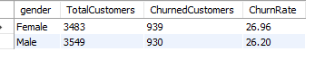

-- Count the number of senior citizens and their churn rate.

SELECT

SeniorCitizen,

COUNT(*) AS TotalCustomers,

COUNT(CASE WHEN Churn = 'Yes' THEN 1 END) AS ChurnedCustomers,

ROUND((COUNT(CASE WHEN Churn = 'Yes' THEN 1 END) / COUNT(*)) * 100, 2) AS ChurnRate

FROM telco_customer

GROUP BY SeniorCitizen;

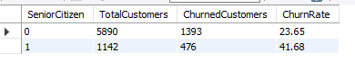

**4. Service Analysis:**

**--** Analyze churn by phone service.

SELECT

PhoneService,

COUNT(*) AS TotalCustomers,

COUNT(CASE WHEN Churn = 'Yes' THEN 1 END) AS ChurnedCustomers,

ROUND((COUNT(CASE WHEN Churn = 'Yes' THEN 1 END) / COUNT(*)) * 100, 2) AS ChurnRate

FROM telco_customer

GROUP BY PhoneService;



-- Analyze churn by internet service type.

SELECT

InternetService,

COUNT(*) AS TotalCustomers,

COUNT(CASE WHEN Churn = 'Yes' THEN 1 END) AS ChurnedCustomers,

ROUND((COUNT(CASE WHEN Churn = 'Yes' THEN 1 END) / COUNT(*)) * 100, 2) AS ChurnRate

FROM telco_customer

GROUP BY InternetService;

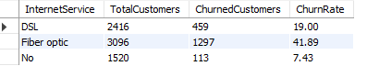

**5. Financial Analysis:**

-- Calculate the average monthly charges for churned and non-churned customers.

SELECT

Churn,

ROUND(AVG(MonthlyCharges), 2) AS AvgMonthlyCharges

FROM telco_customer

GROUP BY Churn;



--Calculate the average total charges for churned and non-churned customers.

SELECT

Churn,

ROUND(AVG(TotalCharges), 2) AS AvgTotalCharges

FROM telco_customer

GROUP BY Churn;



**6. Contract Analysis:**

--Analyze churn by contract type.

SELECT

Contract,

COUNT(*) AS TotalCustomers,

COUNT(CASE WHEN Churn = 'Yes' THEN 1 END) AS ChurnedCustomers,

ROUND((COUNT(CASE WHEN Churn = 'Yes' THEN 1 END) / COUNT(*)) * 100, 2) AS ChurnRate

FROM telco_customer

GROUP BY Contract;

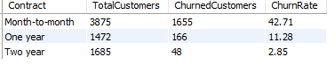

-- Analyze churn by paperless billing.

SELECT

PaperlessBilling,

COUNT(*) AS TotalCustomers,

COUNT(CASE WHEN Churn = 'Yes' THEN 1 END) AS ChurnedCustomers,

ROUND((COUNT(CASE WHEN Churn = 'Yes' THEN 1 END) / COUNT(*)) * 100, 2) AS ChurnRate

FROM telco_customer

GROUP BY PaperlessBilling;

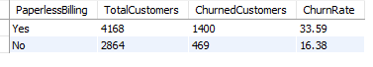

-- Analyze churn by payment method.

SELECT

PaymentMethod,

COUNT(*) AS TotalCustomers,

COUNT(CASE WHEN Churn = 'Yes' THEN 1 END) AS ChurnedCustomers,

ROUND((COUNT(CASE WHEN Churn = 'Yes' THEN 1 END) / COUNT(*)) * 100, 2) AS ChurnRate

FROM telco_customer

GROUP BY PaymentMethod;

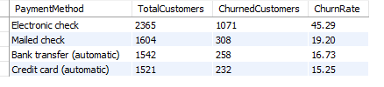

**7. Tenure Analysis:**

--Calculate the average tenure for churned and non-churned customers.

SELECT

Churn,

ROUND(AVG(tenure), 2) AS AvgTenure

FROM telco_customer

GROUP BY Churn;



-- Analyze the distribution of tenure for churned and non-churned customers.

SELECT

Churn,

MIN(tenure) AS MinTenure,

MAX(tenure) AS MaxTenure,

ROUND(STDDEV(tenure), 2) AS StdDevTenure

FROM telco_customer

GROUP BY Churn;

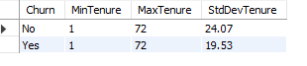

**8. Advanced Analysis:**

--Find customers with the highest monthly charges.

SELECT

customerID,

MonthlyCharges

FROM telco_customer

ORDER BY MonthlyCharges DESC

LIMIT 10;

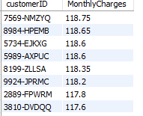

-- Calculate the running total of total charges for each customer.

SELECT

customerID,

TotalCharges,

SUM(TotalCharges) OVER (PARTITION BY customerID ORDER BY TotalCharges) AS RunningTotalCharges

FROM telco_customer;

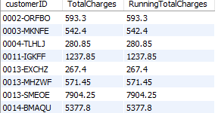

-- find the average monthly charges per contract type.

WITH CustomerSegments AS (

SELECT

Contract,

AVG(MonthlyCharges) AS AvgMonthlyCharges

FROM telco_customer

GROUP BY Contract

)

SELECT * FROM CustomerSegments;

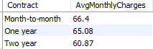

**4. Power BI Visualization:**

* Visualizations Overview

The following visualizations were created to provide insights into customer churn:

- Churn Rate by Gender

- Churn Rate by Senior Citizen Status

- Churn Rate by Internet Service Type

- Monthly Charges for Churned vs. Non-Churned Customers

- Total Charges for Churned vs. Non-Churned Customers

- Churn Rate by Contract Type

- Churn Rate by Phone Service

- Churn Rate by payment method

Each visualization helps to understand different aspects of customer churn.

**Dashboard Design**

Layout and Design:

The dashboard consists of several visualizations arranged to provide a comprehensive view of customer churn. Interactive elements like slicers are used to filter data dynamically.

Key Elements:

- Churn Rate by Gender: Bar chart showing the churn rate by gender.

- Churn Rate by Senior Citizen Status: Bar chart showing the churn rate among senior citizens.

- Churn Rate by Internet Service Type: Bar chart showing the churn rate by internet service type.

- Monthly Charges: Comparison of monthly charges for churned vs. non-churned customers.

- Total Charges: Comparison of total charges for churned vs. non-churned customers.

- Churn Rate by Contract Type: Bar chart showing churn rate by contract type.

- Slicers: Slicers for filtering data by different dimensions like tenure, payment method, etc.

-Using Interactive Elements: Interactive elements such as slicers are used to filter and explore data dynamically. For example, users can filter the data by contract type to see how different contracts impact churn.

Instructions to Access the Dashboard:

1. Open Power BI Desktop.

2. Load the file.

3. Navigate through the different visualizations on the dashboard.

4. Use the slicers to filter the data and explore various insights.

**5.Insights and Conclusions:**

Key Insights:

1.Churn Rate by Gender: The churn rate is similar for both male and female customers, indicating gender does not significantly impact churn.

2. **Churn Rate by Senior Citizen Status: Senior citizens have a higher churn rate compared to non-senior citizens.

3. Churn Rate by Internet Service Type: Customers with fiber optic internet service have a higher churn rate compared to those with DSL or no internet service.

4. Monthly Charges: Churned customers tend to have higher monthly charges on average.

5. Total Charges: Churned customers tend to have higher total charges, indicating they may leave after a significant period of high spending.

6. Churn Rate by Contract Type: Customers with month-to-month contracts have a higher churn rate compared to those with one or two-year contracts.

**6.Actionable Recommendations:**

1. Target Senior Citizens: Develop targeted retention strategies for senior citizens to reduce their higher churn rate.

2. Improve Fiber Optic Service: Investigate and address issues with fiber optic service to reduce churn among these customers.

3. Incentivize Longer Contracts: Offer incentives for customers to switch from month-to-month contracts to longer-term contracts to reduce churn.

Final Thoughts:

By understanding the factors contributing to customer churn, the company can implement targeted strategies to improve customer retention and reduce churn rates.

7. **Appendices:**

Dataset:

<https://github.com/sucharitabi/Churn-Analysis/blob/main/Telco-Customer-Churn.csv>

Power BI Dashboard File:

<https://github.com/sucharitabi/Churn-Analysis/blob/main/churn%20analysis.pbix>